The American political system, while composed of many different parties, is dominated by two main groups, Democrats and Republicans. These two parties raise and spend millions of dollars amongst their members to finance campaigns for various office seats. Amongst all the spending and competition, the question arises: Is it more expensive to be a Democrat, a Republican, or maybe even a third-Party candidate? Using the FEC’s Campaign-finance dataset, we can see just who spends the most.

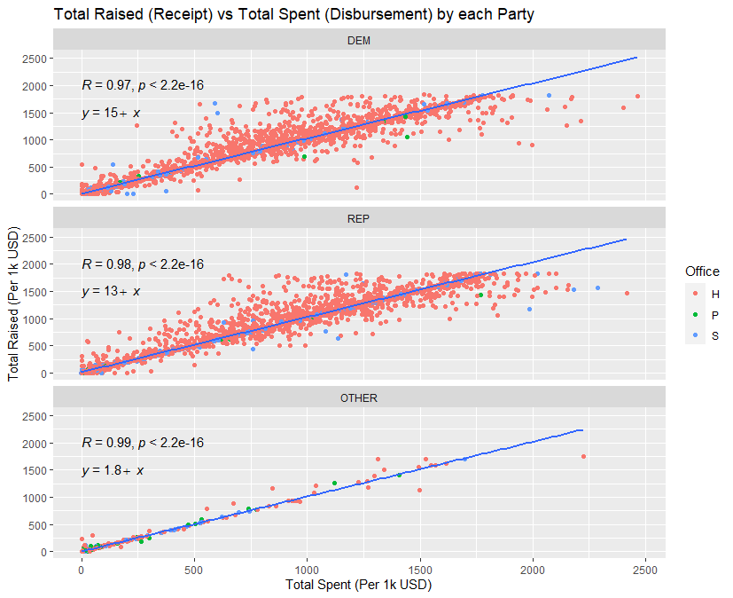  
Figure 1: *Total Receipt plotted against Total Disbursement grouped by each party. Office seats H- house, P- president, S- senate*

As previously mentioned, to finance political campaigns, party members from all sides must raise funds. Seen in figure 1, spending is directly proportional to the amount raised. Most notably is that most of the spending is used on House races. Additionally, based on the intercepts of the lines fitted to each plot, Democrats and Republicans receive more money (approximately 13 and 11 thousand USD respectively) than members of 3rd party groups for each unit of total spending.

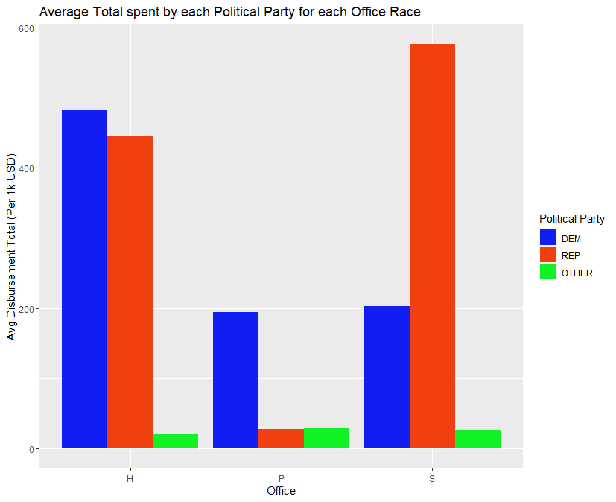

Figure 2: *Average total (disbursement) spent by each political party for specific office seats.*

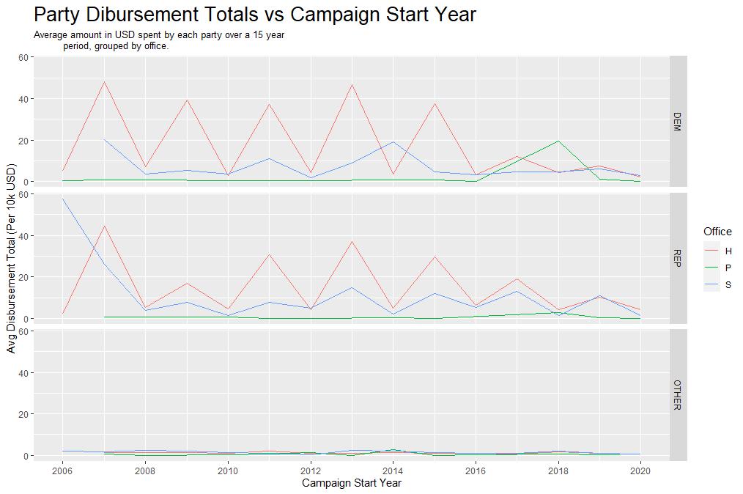  
Figure 3: *Average total spent by each party for specific office seats from 2006-2020*

Based on figure 1, it is evident that the major parties receive more money and embark on many more house campaigns than any other race, but what does this spending look like on average. As seen in figure 2, the two major parties spend much more than all 3rd party groups. In terms of House campaigns, spending from the major parties is roughly the same. However, Democrats spend much more on presidential campaigns while Republicans spend more on Senate campaigns. Interestingly, the average amount spent year to year varies as seen in Figure 3. The amount spent for each race fluctuates amongst the major parties. House campaigns seem to cost the most when they start on odd numbered years (2007,2009, etc.) while the trends for Senate and Presidential races are much more sporadic. Overall, House campaigns spend much more annually than any other office. Additionally, 3rd party candidates appear to spend roughly the same every year.

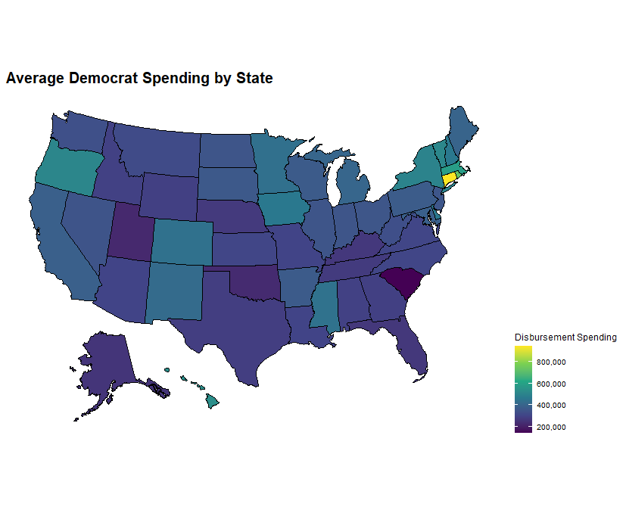 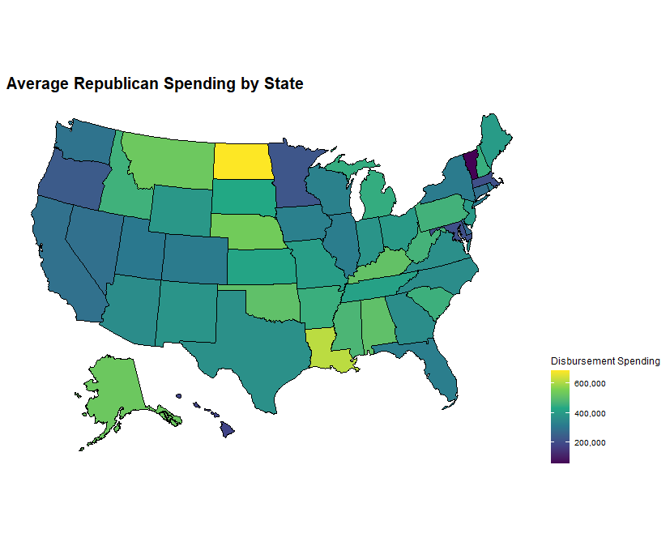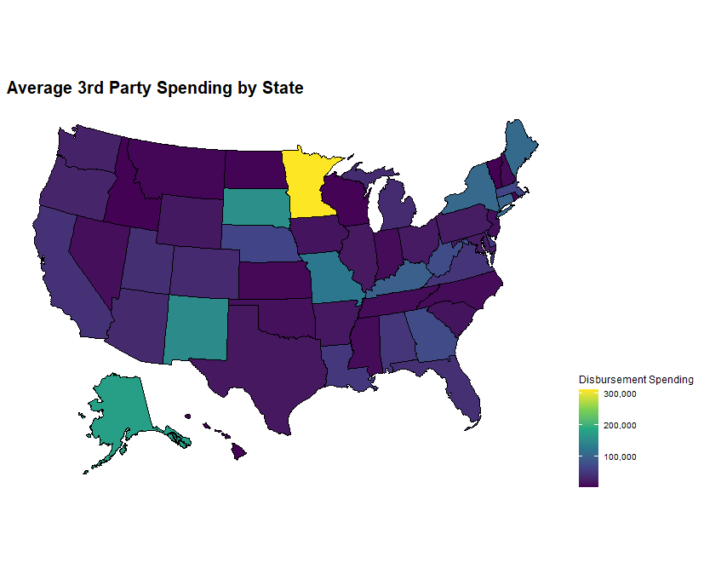

Figure 4: *Average spending for each political party by US States.*

Political candidates come form every state, so how much does each Party’s member spend based on state. Based on figure 4, Republicans seem to spend much more on campaigns no matter what state they are from, while 3rd party candidates spend the least. Democrats seem to spend the more when they come from coastal states, but overall fall in between the range cast by Republicans and 3rd party groups.

Based on the information gathered from the figures presented, it appears that overall, it is more expensive to be a Republican candidate when accounting for office position, state, and annual trends.

The American political system, while composed of many different parties, is dominated by two main groups, Democrats and Republicans. These two parties raise and spend millions of dollars amongst their members to finance campaigns for various office seats. Amongst all the spending and competition, the question arises: Is it more expensive to be a Democrat, a Republican, or maybe even a third-Party candidate? Using the FEC’s Campaign-finance dataset, we can see just who spends the most. 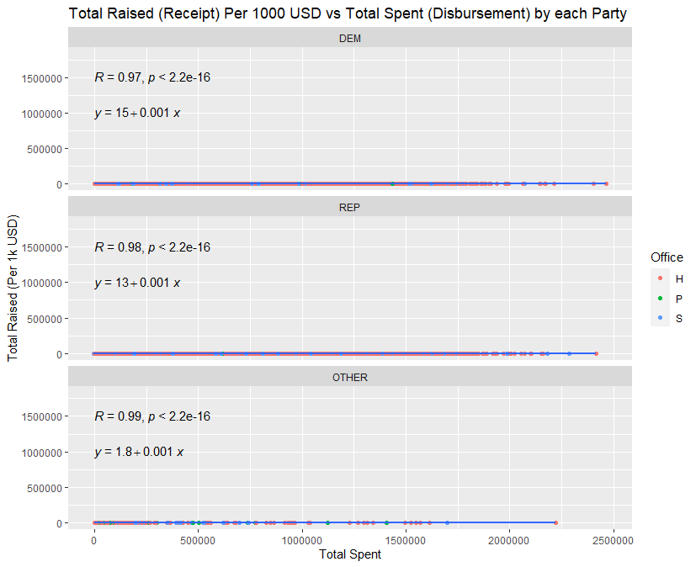

Figure 1: *Total Receipt plotted against Total Disbursement grouped by each party. Office seats H- house, P- president, S- senate*

As previously mentioned, to finance political campaigns, party members from all sides must raise funds. However, as seen in figure 1, spending does not appear to be proportional to the amount raised. In fact, spending appears to not be influenced at all by the amounts raised by each party.

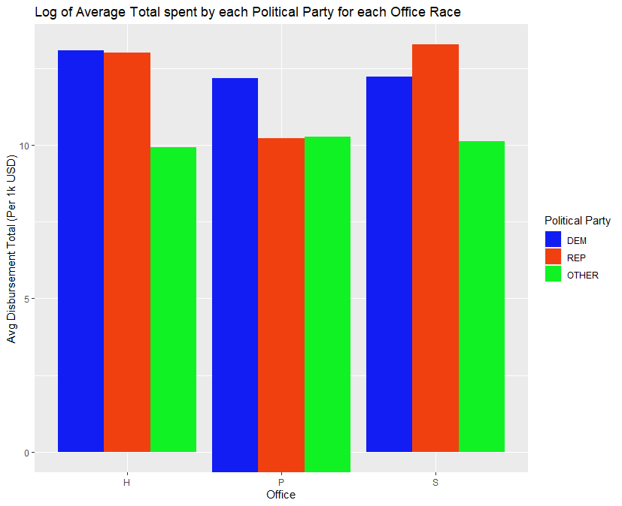

Figure 2: *Average total (disbursement) spent by each political party for specific office seats.*

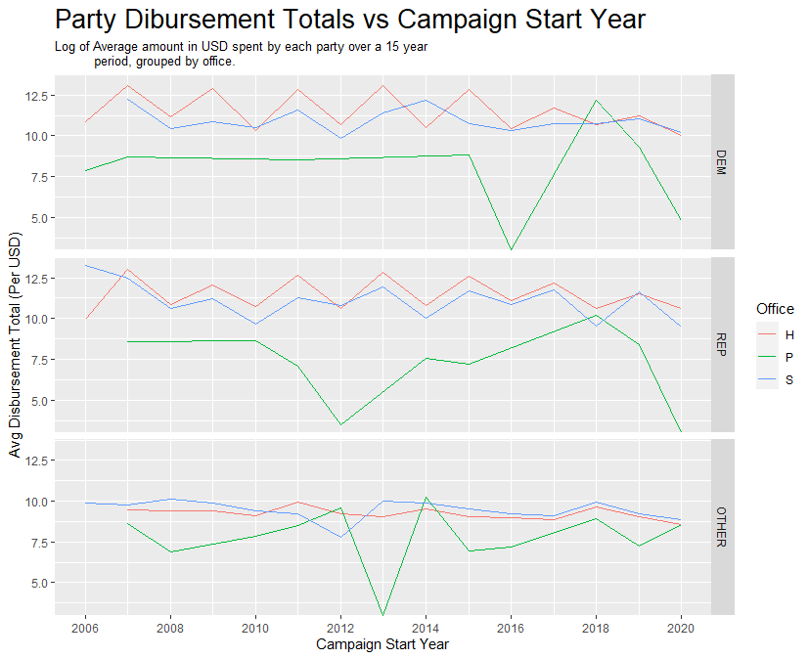

Figure 3: *Average total spent by each party for specific office seats from 2006-2020.*

Based on figure 1, political parties seem to spend the same range of values when it comes to campaigning, but what does campaign spending look like on average. As seen in figure 2, there does appear to be some difference between the three groups. Democrats appear to spend the most on House and Presidential campaigns while Republicans spend the most for senate races. However, the difference between the two main groups seems minimal. The largest difference is only ~3 units, based on the y-axis. In terms of the amount spent year to year, the difference in political party spending is visualized in figure 3. Based on this figure it appears that spending on House and Senate campaigns are roughly periodic while presidential campaigns have sharp spike and crashes over time. Similarly, to figure 2, the difference in campaign spending (except for the President) is roughly the same amongst Democrats and Republicans, while 3rd party members spend the least.

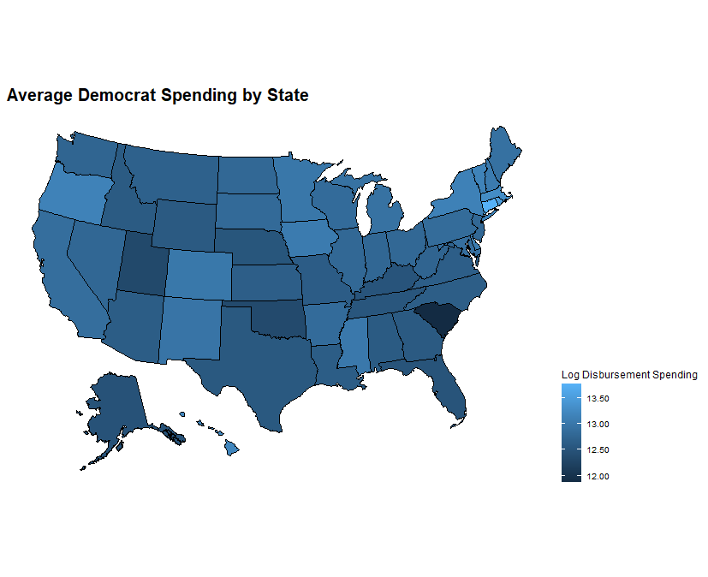 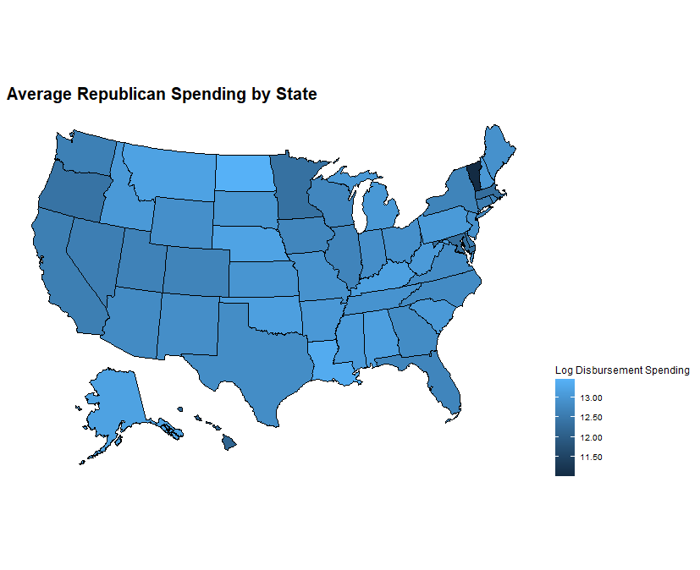 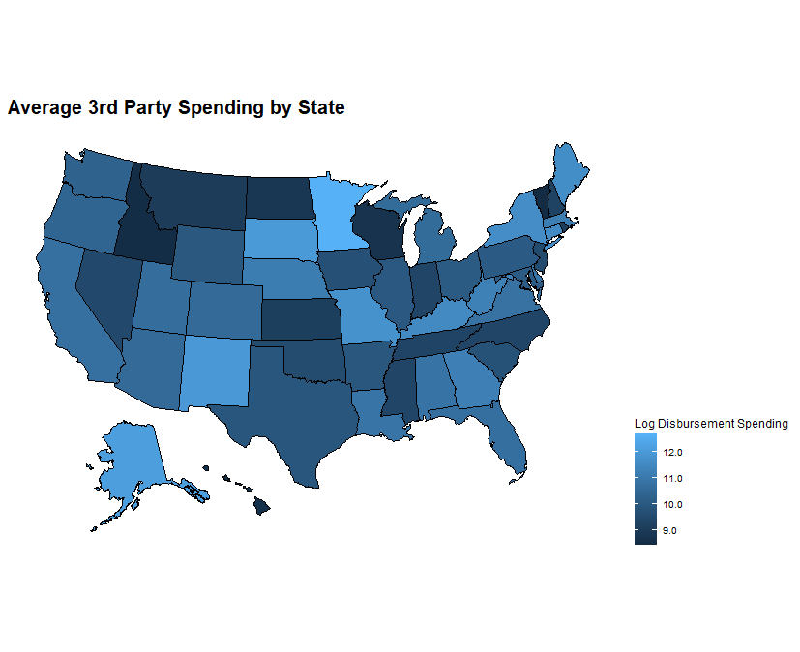

Figure 4: *Average spending for each political party by US States.*

When observing average spending by state, there does appear to be a difference in party spending. It appears that overall, Republicans spend more than either of the other parties while 3rd party candidates spend the least. When considering the findings of figure 1, 2 and 3, the difference in states does not appear to be drastic enough to say that any one party spends more than the next. Therefore, based on the data presented in these figures, it appears that it is just as expensive to be a Republican as it is to be a Democrat.

The American political system, while composed of many different parties, is dominated by two main groups, Democrats and Republicans. These two parties raise and spend millions of dollars amongst their members to finance campaigns for various office seats. Amongst all the spending and competition, the question arises: Is it more expensive to be a Democrat, a Republican, or maybe even a third-Party candidate? Using the FEC’s Campaign-finance dataset, we can see just who spends the most. 

Figure 1: *Total Receipt plotted against Total Disbursement grouped by each party. Office seats H- house, P- president, S- senate*

As previously mentioned, to finance political campaigns, party members from all sides must raise funds. However, as seen in figure 1, spending does not appear to be proportional to the amount raised. In fact, spending appears to not be influenced at all by the amounts raised by each party.



Figure 2: *Average total (disbursement) spent by each political party for specific office seats.*



Figure 3: *Average total spent by each party for specific office seats from 2006-2020.*

Based on figure 1, political parties seem to spend the same range of values when it comes to campaigning, but what does campaign spending look like on average. As seen in figure 2, there does appear to be some difference between the three groups. Democrats appear to spend the most on House and Presidential campaigns while Republicans spend the most for senate races. However, the difference between the two main groups seems minimal. The largest difference is only ~3 units, based on the y-axis. In terms of the amount spent year to year, the difference in political party spending is visualized in figure 3. Based on this figure it appears that spending on House and Senate campaigns are roughly periodic while presidential campaigns have sharp spike and crashes over time. Similarly, to figure 2, the difference in campaign spending (except for the President) is roughly the same amongst Democrats and Republicans, while 3rd party members spend the least.

 

Figure 4: *Average spending for each political party by US States.*

When observing average spending by state, there does appear to be a difference in party spending. It appears that overall, Republicans spend more than either of the other parties while 3rd party candidates spend the least. When considering the findings of figure 1, 2 and 3, the difference in states does not appear to be drastic enough to say that any one party spends more than the next. Therefore, based on the data presented in these figures, it appears that it is just as expensive to be a Republican as it is to be a Democrat.